
SE-1000 - User Overview

With the growing popularity of HD video production, the Datavideo SE-1000 Switcher Package is an interesting and viable choice for small production companies, churches, OB vans and corporate production departments. It supports live production using, 5 inputs (HDSDI or SDI) plus one computer and one still frame. And, it has three outputs (HDSDI or SDI).
Today, it is a 7-input standard definition or high definition SDI input mixer available by itself or in various kits that make it a “ready-to-go” system. The SE-1000 fits well with cameras that output standard SDI or HD-SDI. This includes broadcast and studio cameras and camera heads, as well as prosumer camcorders.

One kit is a lightweight stand that holds two, 2RU banks of three 16:9 LCD monitors in addition to accommodating another 1RU device, like Datavideo's innovative 8-channel intercom / tally system that will illuminate Datavideo's LED tally lights or your own. This way you can plug in you cameras and start mixing a show in just minutes.
Another kit puts the mixer, monitors, communication, and more, all inside a convenient “road” case that lets you leave everything connected and in place. When you get to your destination, you just take off the front and back panels, slide out the locking mixer drawer, and power everything up. A really handy part of this system is the PD-1 Power Distributor. This 1RU device accepts AC or DC inputs, and then provides three AC outlets, two 4-pin 12v supplies and seven 5v DC supplies- enough to power an entire rack of Datavideo gear with just one AC cord.

Datavideo offers a system of coordinated pieces that conveniently integrate into an existing production work flow or work as a stand alone system. In addition to the switcher with included tally lights and rack mount monitors Datavideo’s HD products include a HDSDI/SDI distribution amplifier p/n VP445 and a 17” LCD monitor p/n TLM-170. The ITC-100 8 Channel intercom

Please check the website for the most recent product information.

Switcher Package Includes:  SE-1000 HD/SD Digital Video Switcher  2- TLM-433 (3 - 16:9 SD Composite monitors)  1- RKM-3N3 Holder for the two monitors and an intercom  1 - TB-10-Tally Box  6 - Tally Lights | 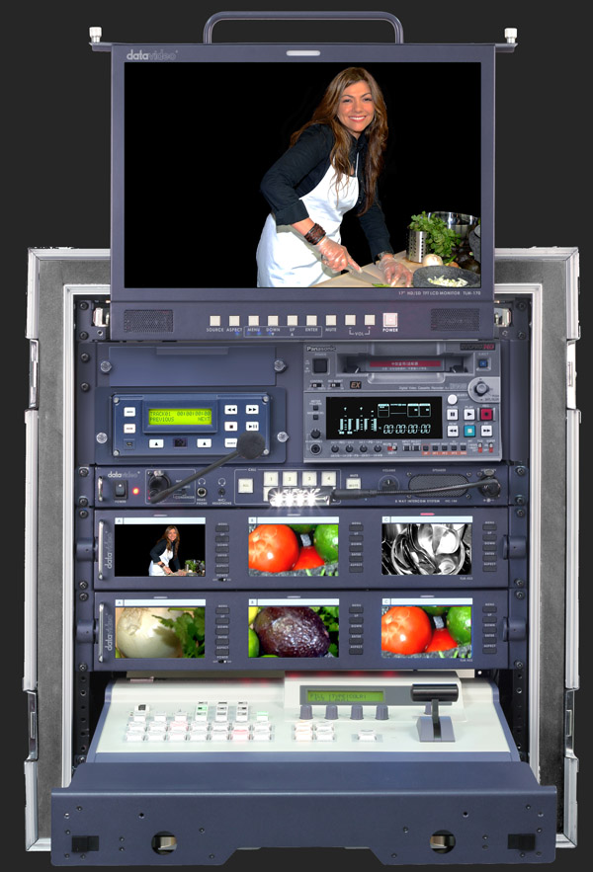  The MS-1000 Mobile Studio includes:  1 – Case CCS-MS-1000  1-SE-1000  2- TLM-433 monitors  1 -TB10 Tally box  6 - Tally Lights  1- ITC-100 Intercom with SE-1000 kit | Dimensions / Weight / Power Requirements  Width: 17 inches, 430 mm  Depth: 16.8 inches, 420  Height: 4.72 inches, 120  Net Weight: 14 lbs, 6.4 kgs  What are the power requirements – ask Steven
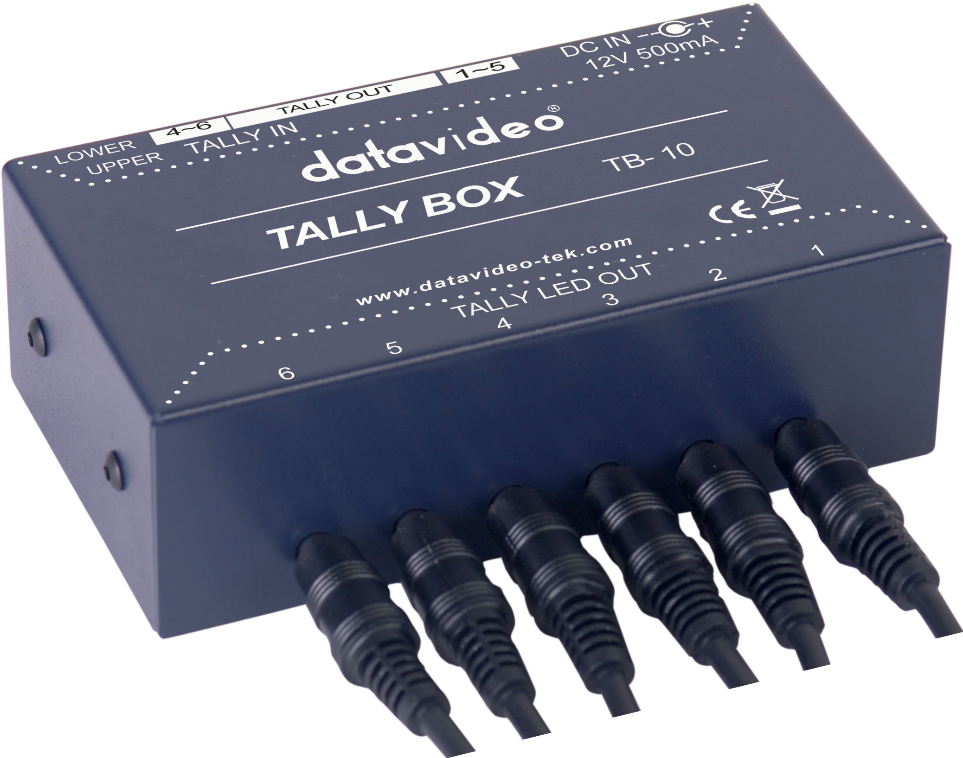  TB-10 Tally Light control – included with the SE-1000 package |   LED Tally Lights – included with the SE-1000 package  Tally Light extension cables  25’ – TLT-CA25  50’ - TLT-CA50  75'- TLT-CA75 | VP-455 - The HDSDI/SDI distribution amplifier comes in a small package and works on 12vDC so it can be used in a van or on location. A 110/220 power supply is included.
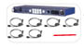  ITC-100 Intercom with tally lights. For the SE-1000 order the ITC-100 + SE-1000 kit. | 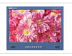  TLM-170  The monitor comes in three configurations – rack mount, table top and a 1RU high rack mounted pull out drawer – similar to a pull out key board. | 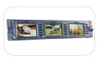  TLM-433 A 19” rack mount display with three 16:9 SD composite video monitors.

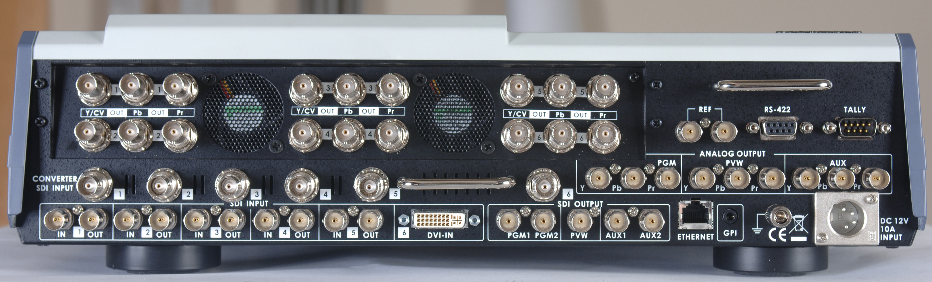

Tomorrow, the SE-1000 also enables you to seamlessly grow with technology as your world moves to HD. You can turn a dial, and instantly, the SE-1000 is a full-on 16:9, 1080i HD mixer. If you need a 720p mixer- it’s that too. In addition, the SE-1000 has 6-channels of independent SDI –> analogue video conversion built in. These converters are completely independent of the video mixing capabilities. There is also a 1-channel AUX router. Each of these will be explained in a minute.

Let's begin by describing four different scenarios where the SE-1000 shows off its unique talents.

Corporate video:
Say you are a corporate video department. In today’s worldwide economy, you need to be able to handle and provide video formats for use around the world. No matter if in your studio you are 480i standard def, or 720p high def, or 1808i high def. You’ll likely be required to provide video in a format different than you are producing in-house. With the SE-1000 this is very easy.
You’ve already set up your SE-1000 in a Datavideo rolling case which makes it easy to move it from room to room. You can also put the doors on the case to easily and safely transport the whole system between buildings or facilities. Visit the web site for information on the various cases available.
You’ve got a normal gig today. Using JVC 720p gear in the US, you’ll dial in the 720p59 setting in the Se-1000 mixer and plug the cameras right into the SDI inputs on the mixer. Connect your HD-SDI monitors to the loop-through jacks. Optionally, you can use the built-in converters to connect the TLM- 433 16:9 LCD monitors– either in the integrated CCS-M1 table-top case, or the RKM-3N3 holder. This lightweight stand holds six widescreen LCD monitors so you can easily view every SDI input into the mixer.
Plug the computer into the DVI port on the mixer. With this, you can directly feed a PowerPoint presentation, full screen still images, or use the SE-1000 internal key capability for full color lower thirds and other on-screen graphics. Datavideo’s own CG-200 software offers both SD and HD outputs so you can handle graphics for any type of event. The SE-1000 can be set to stretch incoming 4:3 computer video if needed, or leave it with black bars left and right.
Connect your JVC deck to the output of the switcher and you're ready to start mixing a show.

But this week, European guests brought their Sony HDV deck. This means they need a 1080i50 (50 Hz is used in Europe and many other parts of the world) feed from your 720p59 feed (59 matches the 60 Hz use in the US). You not only have to convert from 720p to 1080i, you have to convert from the US 60 Hz to the European 50 Hz. With the SE-1000 can do this in less than a minute with no additional hardware.
Connect a short BNC cable between program output SDI jack to any one of the 6 internal converter inputs. Let’s say you use #5. It doesn’t matter which one you use. Then, on the top panel of the SE-1000, you can adjust the converter settings to change input #5 to your desired output. Do this by depressing the dial knob to change the HD feed and rotating the dial from 720p59 to 1080i50. Then depress the knob again to select this new setting. You’re done. Now the component output of #5 can be connected directly to the deck your European guests brought and they can record the video of your program in their native format.

At the last second, they pull out a laptop ask for a composite, standard definition feed for a live webcast. This is something a lot of companies are doing more of so they can save from paying costly travel expenses for the majority of distant attendees. Without missing a beat you pull out two more BNC cables and get ready for another thirty seconds of work.
You connect the second SDI program output to converter input #6. Again, it doesn't matter which one you use. They are all completely independent and all have the same, full capability. You go into the Converter settings for #6 and first change the output from HD to SD. Then you check the format of the SD settings and with one click of the dial, change from NTSC to PAL- 570i50. This is easy. Lastly, you can choose between sending out Y,U,V on three BNC jacks or composite video on one BNC jack. The little USB video device they brought only has composite video in. You choose composite and that's it. Connect the cable between composite output #6 and their USB device and you're done.
You are converting your US-standard, high definition program to two different European standards, HD and SD just by using the hardware already built into the SE-1000. There's nothing else needed.

With the SE-1000 as the core of a Datavideo Mobile Studio kit, you can take your production anywhere it is needed with ease, and handle most any format and standard conversion for delivery.

Rental House:
A rental house may need to set up the SE-1000 for two different rental jobs in one week.
The Wednesday job will use five Canon camcorders for a standard definition job in Atlanta, Georgia. So you dial the internal format of the SE-1000 to 480i59 and set your camcorders to standard definition.
They will also be using a computer for PowerPoint slides during the show. A DVI splitter sends the output of their laptop can be sent to both a video and the DVI input of the SE-1000. The mixer will automatically scale both the frame size and the frame rate of the computer to the video program settings.
With SDI you can easily go hundreds of meters or feet with good quality cable. Use a DB-15 cable to connect the SE-1000 to the Datavideo TB-10 tally box. It has six 3.5mm (1/8") jacks to run tally lights on each camera. These tiny LED indicators have hook-&-loop straps to wrap around each camcorder. The indicators use bi-color LEDs to indicate when a camera is on the preview bus (yellow) and when it is on the program bus (red). This is very handy. These LEDs are easily viewable in front of and behind the camcorder.
The SE-1000 has a full frame sync for all inputs. This means you just have to run one video cable to each camcorder, not two. This cuts the amount of cable you need in half. You include the Datavideo CG-200, which does SD and HD graphics. It is rack-mounted and quickly learned. You package the switcher, monitors and the CG in the MS-100 Mobile Studio package for convenience and protection.
This customer is providing their own communication system.
You rent them two DVCAM decks, which will get their audio from the sound mixer and use the component video outputs of the SE-1000. The client mentioned that they need an isolated (ISO) feed of the close-up camera on the singer. This is fairly common. The big decks will let them use 184 minute tapes- for over three hours of continuous taping. This will ensure they get every minute of the performance.
The close-up camera will be camera #3. So you push and hold the AUX button and then, on Preview Bus B, you push button #3. You'll see it light up yellow while you hold the AUX button down. Then let go of both buttons. Now the component AUX output will be camera #3 and it will remain constant no matter what.
The tally lights will jump from camera to camera as your clients mix the show.

Thursday, you set up the SE-1000 for a HD live musical show on the weekend. It will mix the video displayed on a large screen behind the performers. Some call this "IMAG" meaning Image Magnification– where you make everything much larger so people far from the stage can clearly see it. There will be computer input, slides, and 5 camcorders. The director also has a particular way he likes to have his mixer set up. The internal crosspoint switch of the SE-1000 will facilitate this.
First, you set both the mixer and the camcorders for 1080i60. Next, you use the crosspoint switch to internally route the cameras to inputs 3, 4, 5, 6, 7- with #7 being the wide camera in the back. This is how the director likes to have things arranged. Then you set the internal Frame MEMory to be #2. Lastly, you set the computer input (jack #6 on the back of the SE-1000) to #1 so it is the furthest from the main wide camera. The SE-1000 lets each user set up the mixer in a way that is most comfortable to them.
You use the included software to download still images into the internal Frame MEMory. This is what is sent to button #2 on the mixer. The stills in the memory can be selected through a setup menu during the mixing of the live show. The band will use it to show stills of their world tour during certain songs. You can easily mix to and from the Frame MEMory just as if it were any other camera input.
Lastly, the computer input, which is now on mixer button #1, will be used to play back pre-recorded video clips, graphics, and utilized by a live Video DJ to mix clips "on the fly" during the show as an exciting live element to the stage show. The SE-1000 internal scalar ensures that the high quality of the computer DVI input is maintained out to the 1080i HD video output.
With so much to keep track of, the crew of this show also rents the Datavideo ITC-100 intercom system. This is similar to other "party-line" systems but also adds tally lights for each connection. The SE-1000 mixer controls these tally light indicators. Only one 5-pin cable is needed for each each camera to provide both the full-duplex communication, and the tally system. This helps camera operators really know when they are "on" during slow dissolves or split-screen effects– when two cameras may be "live" for a long time. Both cameras will have red tally lights the entire time they are live. There is no need to keep announcing, "Camera 4, you are still live... still live... don't move... still up..." etc. This reduces com chatter and helps everyone focus on their job.

Datavideo mixers are simple to understand and operate. The some have menus that enable and adjust deeper features, but the overall simplicity of the mixers is matched only by their professional results.
Another key aspect to Datavideo is support after the sale. From firmware upgrades, to repairs or upgrades, Datavideo is large enough to enable studios to change and adapt to future needs. Yet, Datavideo also enables you to speak directly to a sales or support with one phone call. In fact, a live person picks up the phone at the Datavideo U.S. headquarters. This way, if a someone breaks a knob, you can quite easily arrange to have it fixed and get the gear back into service.

School Studio:
For studios making a cost-conscious, multi-step transition to HD, the SE-1000 may be their first purchase– specifically because it is a standard definition mixer now, yet offers more capability than most 4-input mixers. Then, after HD cameras and decks are added, the whole system can be upgraded to HD just by changing menu settings on each piece of gear. Those SDI cables connecting all the gear will have different "water" flowing inside them- instead of standard def-SDI it will change to HD-SDI.
Many studios have camera systems and CCU (camera control units) that offer SDI outputs. No matter if these are just standard definition, the key is that the SE-1000 uses this single-wire simplicity. SDI offers excellent signal integrity for all the inputs over short or long cable runs.
A valuable feature of the SE-1000 for lower-budgeted studios is the internal converter. By using the 6-channels of SDI to analogue conversion, the studio can keep using all their old composite monitors for all 6 of the camera inputs. Short jumper cables between the loop-through for each SDI camera input, and feed it into the SDI input of the corresponding converter. Then set each converter to SD, 480i, composite video. Then they can connect composite video cables to any monitor they already have.
In this way, they've taken the first step to HD production without forcing themselves to throw away any of their other gear. The SE-1000 slips neatly into existing production environments and lets studios upgrade components around the mixer over time. Next year, the studio can get a few widescreen SDI monitors… a HD deck. Then, a grant enables them to buy a few HD cameras. All of a sudden, without ever being forced to obsolete any one component, they can change a few menu settings and everything from the cameras, mixer to deck, as well as camera monitoring, is in HD.

Worship:
As the congregation grows, you need to add technical capability, and more “pizzaz” to the program shown on the big screens, in videos, or online. You may need to add video to an overflow room. Whatever the cause, you need more capability and higher quality than you had before.
If you were using “S” video, you might be surprised that the right “Composite” cable will give you better video– the trick is that you’ll use SDI which is a completely digital interface, as opposed to analogue composite, even though the cable looks the same. If you were using Firewire before, you had to deal with the multi-frame delay (2 frames in the camera, 2 frames at the switcher, 2 frames in the deck, …) This also disappears with SDI. Gone are the days when the screens were visibly delayed from reality.
With the DVI input, the SE-1000 lets you incorporate high quality graphics and overlays for song lyrics, prayers and more. You can easily jump to PowerPoint slides, or any other computer output, including video playback. This enables you to easily create a dynamic video presentation to accompany the service.
In addition, you can augment your new, high-quality video with real-time recording to hard drive or DVD. A hard drive enables you to edit the show without ever waiting to digitize it. All these tasks are easily facilitated, even with part-time or volunteer staff, with the easy-to-use accessories from Datavideo like the MP-6000 DVD burner or DN-300 hard drive recorder.
By building a complete kit from one supplier you have only one phone number to call if there’s a problem with any of the components. You can quickly get an answer to your question, or fix a problem by reaching an experienced customer service representative or technician at Datavideo.

Mixer Overview:
With these examples, you can now see how the SE-1000 is great for rental houses or freelancers because it's one box that serves all three formats equally well. The switcher does not scale mixed format sources- instead you pick an operational format and you make sure the inputs match that format. If they don't, the input will appear black (empty.) But there's no single box that combines all the talents of the SE-1000 for anywhere near the price.
The feature is the 7 inputs. This is far more useful than the tiny 4-input mixers that have been available for so long. Six are SDI inputs and only SDI inputs. The seventh is dedicated to computer input with DVI. This DVI input is scaled and sized to the current operational format of the switcher. You have critical control of the DVI scale, position and sync. Moreover both analogue and digital DVI is supported. Because everything is digital, picture quality is exceptional.
Don't worry about genlock, The SE-1000 has an internal 1-frame sync to lock up any and all sources. You can "hot-punch" between any of the seven inputs- this includes the computer DVI input. This greatly facilitates setup because you have 1-wire simplicity. On the other hand, if you can genlock everything, you can turn off the internal frame sync and the delay is one line. Perfect for live events where minimal delay is required.
The 6 other sources come in SDI (either HD SDI or SD SDI) and there's a loop through to feed a monitor. Black, colored backgrounds and bars are generated internally. Should a camera go dead, you can have the SE-1000 hold the last frame, or just go to black. Best of all, you can set up the mixing bus just how you like it by adjusting the built-in crosspoint switcher. Maybe you like Black on input one. Maybe you want the computer (#6) on input 1. Note, though, that assigning black, color bars, and a computer counts against those 7 inputs.
The SE-1000 offers program and preview outputs in both SDI and analogue component. These are in the operational format of the switcher. There is also an AUX bus that can be selected and changed in an instant- without ever touching a menu. This AUX output can be any of the 7 inputs, preview, program or a clean program. This is useful for an isolated recording of a single camera, or a clean (graphics free) recording of the mixed show. Or you can send the graphics input to a monitor on stage for talent to see. It's completely up to you and completely independent of the main program mix.
The last key feature of the SE-1000 is an internal, yet completely independent, 6-channel SDI to analogue video converter. This is important to understand that, though internal, this format converter is completely independent of the video mixer itself. It is designed to compliment and enhance the usability of the SE-1000 for the disparate needs of different customers. It does not take component inputs to the mixer and convert them to SDI, it only converts from SDI to component or composite. It accepts standard def or high def. It outputs in all 6 standards, either component or composite. The examples above illustrated a few of the useful capabilities of these powerful, internal format and standard converters.
The AUX output signals can be stored in the SE-1000's frame memory for use later. Stored images can be used on any input by adjusting the cross-point assignment from camera or black to the Frame MEMory. There is an ethernet port for the SE-1000 to communicate with a computer. Software (included) is used to both save or load image date into the internal frame memory. Standard image files are supported. This way, the mixer can be preloaded with numerous slides for use during a video program.
Lastly, the SE-1000 has a tally port to communicate with the stand-alone TB-10 Tally Box, or the ITC-100 Communication System so that camera operators and talent are both clearly aware of what camera is live, and what camera is next. The Tally system uses on-camera LED lights that face both the talent and the operator. Direct integration with the SE-1000 makes it easier for camera operators to know when they are "hot."
All these features rolled into one compact mixer, with no external connector box or hardware, at a price point that has no competition.

What is 16:9, 1080i HD
From: http://en.wikipedia.org/wiki/1080i
1080i (pronounced "ten eighty I") is shorthand name for a category of video modes. The number 1080 stands for 1080 lines of vertical resolution, while the letter i stands for interlaced or non-progressive scan. 1080i is considered to be an HDTV video mode. The term usually assumes a widescreen aspect ratio of 16:9, implying a horizontal resolution of 1920 pixels and a frame resolution of 1920 × 1080 or about 2.07 million pixels. The frame rate in hertz can be either implied by the context or specified after the letter i. The two frame rates in common use are 25 and 30 Hz, with the former (1080i25) generally being used in traditional PAL and SECAM countries (Europe, Australia, much of Asia, Africa), the latter (1080i30) in traditional NTSC countries (e.g. United States, Canada and Japan). Both variants can be transported by both major digital television formats, ATSC and DVB.
Some people prefer to use the line number of fields, which is half that of frames, in their nomenclature and thus call this mode 540i, likewise 240i and 288i. Others, including the European Broadcasting Union (EBU), prefer to use the field rate separated with a solidus from the resolution as in 1080i/30 and 1080i/25, likewise 480i/30 and 576i/25.
1080i is directly compatible with CRT-based HDTV sets. CRT-based HDTV never entered the market in large volumes. 1080i is compatible with newer 720p- and 1080p-based televisions but must be deinterlaced first in order to be displayed on those sets.
Due to a revision of the NTSC format when color became available, the frame rate of actual 1080i broadcasts is usually 0.1% slower than is implied. For example, a 1080i30 or "30 Hz" transmission actually displays about 29.97 frames each second. Both the straight 24/30/60 and 23.976/29.97/59.94 frequencies are supported by current standards.
Progressive format 1080p50 or 60 is foreseen as the future broadcasting standard for production[1].

1080i vs 1080p
To compare 1080i and 1080p it is important to compare framerates. Due to interlacing 1080i has twice the frame-rate but half the resolution of a 1080p signal using the same bandwidth. This is especially useful in sport-shows and other shows with fast-moving action. However, on some flat screens that don't support interlacing, this instead becomes smeared or jarred artifacts.
Current digital television broadcast systems and standards are not equipped for 1080p50/60 transmission. Also, the majority of consumer televisions offered for sale are currently not equipped to receive or decode a 1080p signal at any frequency. It is less bandwidth-intensive to broadcast a film at 1080p24 than 1080i30, since 20% less data would be transferred. In addition, when the source material is 24 frames per second, as are most films, it would be easy to convert a 1080p24 broadcast to an NTSC 1080i30 format using a 3:2 pulldown process (see telecine). Moreover, displaying a p24 broadcast on an i50 system (such as PAL) requires the speed of video and audio be increased by over 4% (to 25 frames per second).
For movies the frames (25 or 30 per second) are segmented into two interlaced fields with equal time index (psf, progressive in or with segmented frames). The deinterlacer has to perform a simple weave only. This ensures compatibility with 1080i25/30 with only little less coding efficiency than 1080p25/30 and half the bandwidth requirement of 1080p50/60, but the SDTV problems of PAL speed-up and Telecine judder remain.

WHAT IS 720P?

The term 720p refers to 720 lines of progressive video (720 lines per frame).

From: http://en.wikipedia.org/wiki/720p#720p_versus_1080i
720p is the shorthand name for a category of HDTV video modes. The number 720 stands for 720 lines of vertical display resolution, while the letter p stands for progressive scan or non-interlaced. When broadcast at 60 frames per second, 720p features the highest temporal (motion) resolution possible under the ATSC standard. Progressive scanning reduces the need to prevent flicker by filtering out fine details, so spatial (sharpness) resolution is much closer to 1080i than the number of scan lines would suggest.
Specifications
720p assumes a widescreen aspect ratio of 16:9, and a horizontal resolution of 1280 pixels for a total of about 0.92 million pixels. The frame rate (in this case equal to the field rate) can be either implied by the context or specified in hertz after the letter p. The five 720p frame rates in common use are 24, 25, 30, 50 and 60 Hz (or fps). In general, traditional PAL and SECAM countries (Europe, Australia, much of Asia, Africa, and parts of South America) are or will be using the 25p and 50p frame or field rates, whereas traditional NTSC countries (North and Central America, Japan, South Korea, Philippines) are using 24p (for movies), and 60p for high motion programming. All variants can be transported by both major digital television formats, ATSC and DVB.
Compatibility
720p is directly compatible with newer flat panel technology such as plasma and LCD which are inherently progressive and must perform deinterlacing to display 1080i source material. 720p must be scan converted for display on most CRT-based consumer televisions which are generally interlaced-only display devices.[1] However, CRTs intended for use as computer monitors are progressive-only devices that can be run at 1280×720p60 either natively or through a refresh rate tweaking utility.
History
720p was designed at AT&T Bell Laboratories in the late 1980s, under the supervision of Arun Netravali. The project began when Zenith approached AT&T to partner in the design of an analog HDTV format, comparable to the Japanese system. Netravali (in Murray Hill), along with Barry Haskell (in Holmdel) and other image processing experts at Bell Labs, and William Schreiber at MIT, quickly devised a digital standard using DCT block coding. About 50 engineers were hired and a prototype was assembed in Murray Hill using Xilinx programable logic hardware. The leaders of Zenith and AT&T cancelled the analog-HDTV project after the completion of the digital 720p experimental system, and Zenith agreed to design a radio-frequency modem system for broadcasting digital video. The 720p system was tested against competing standards during FCC trials, and was particularly notable for its lack of flicker and shimmer of moving edges. The conflict between interlaced formats (supported by the television industry) and progressive scan formats (supported by AT&T, Microsoft and others) was extremely contentious in the early days of format proposals.
720p versus 1080i
Some United States broadcasters use 720p60 as their primary high-definition format; others use the 1080i standard. While 720p presents a complete 720 line frame to the viewer between 24 to 60 times each second (depending on the format), 1080i presents the picture as 50 or 60 partial 540 line "fields" per second (24 complete 1080-line fields, or "24p" is included in the ATSC standard though) which the human eye or a deinterlacer built into the display device must visually and temporally combine to build a 1080 line picture - in CRT type display. To get all 1080 interlaced lines to appear on the screen at the same time on a progressive high-definition display, the processor within the HD set has to weave together both 540-line segments to form the full-resolution frame. It does so by holding the first field in its memory, receiving the next field, then electronically knitting the two fields together. The combined fields are displayed at once as a complete 1080p frame. The main tradeoff between the two is that 1080i may show more detail than 720p for a stationary shot of a subject at the expense of a lower effective refresh rate and the introduction of interlace artifacts during motion. 720p is used by ABC and ESPN because the smoother image is desirable for fast-action sports telecasts. Fox Broadcasting Company uses the tagline "the nation's finest high-definition standard" in advertising its 720p programming.
The European Broadcasting Union (EBU) recommends to its members to use 720p50 for emission with the possibility of 1080i50 on a programme-by-programme choice and 1080p50 as a future option.[2][3] The BBC is one of the EBU members transmitting in HDTV. It has not yet made a final decision on picture scanning format. Sveriges television in Sweden and Cyfra+ in Poland broadcast in 720p50. All other commercial European HDTV services so far use 1080i50.

